**a. Implement Insert Operation in Laravel with GUI.**

**Code snippet:**

**addbook.blade.php**

<!doctype html>

<html lang="en">

<head>

<title>Title</title>

<!-- Required meta tags -->

<meta charset="utf-8">

<meta name="viewport" content="width=device-width, initial-scale=1, shrink-to-fit=no">

<!-- Bootstrap CSS v5.2.1 -->

<link href="https://cdn.jsdelivr.net/npm/bootstrap@5.2.1/dist/css/bootstrap.min.css" rel="stylesheet"

integrity="sha384-iYQeCzEYFbKjA/T2uDLTpkwGzCiq6soy8tYaI1GyVh/UjpbCx/TYkiZhlZB6+fzT" crossorigin="anonymous">

</head>

<body>

<header>

<!-- place navbar here -->

</header>

<main>

</main>

<footer>

<!-- place footer here -->

</footer>

<!-- Bootstrap JavaScript Libraries -->

<script src="https://cdn.jsdelivr.net/npm/@popperjs/core@2.11.6/dist/umd/popper.min.js"

integrity="sha384-oBqDVmMz9ATKxIep9tiCxS/Z9fNfEXiDAYTujMAeBAsjFuCZSmKbSSUnQlmh/jp3" crossorigin="anonymous">

</script>

<script src="https://cdn.jsdelivr.net/npm/bootstrap@5.2.1/dist/js/bootstrap.min.js"

integrity="sha384-7VPbUDkoPSGFnVtYi0QogXtr74QeVeeIs99Qfg5YCF+TidwNdjvaKZX19NZ/e6oz" crossorigin="anonymous">

</script>

<div class="container mx-auto w-50 rounded m-5 p-5 bg-dark text-white ">

<h2 class="text-center">Add Book</h2>

<form method="POST" action="{{$url}}" class="px-4">

@csrf

<div class="mb-3">

<label for="exampleInputEmail1" class="form-label">Name</label>

<input type="text" value="{{isset($edit) ? $r[0]->name:""}}" name="name" autofocus class="form-control" id="exampleInputEmail1" aria-describedby="emailHelp">

<span>

</span>

</div>

<div class="mb-3">

<label for="exampleInputPassword1" class="form-label">Author</label>

<input type="text" name="author" class="form-control" id="exampleInputPassword1">

</div>

<div class="mb-3">

<label for="exampleInputPassword1" class="form-label">Year</label>

<input type="text" name="year" class="form-control" id="exampleInputPassword1">

</div>

<div class="mb-3">

<label for="exampleInputPassword1" class="form-label">ISBN</label>

<input type="text" name="isbn" class="form-control" id="exampleInputPassword1">

</div>

<div class="btn d-flex justify-content-center ">

<button type="submit" class="btn btn-primary">Submit</button>

</div>

</div></form>

</div>

</body>

</html>

**DBCONTROLLER.php**

<?php

namespace App\Http\Controllers;

use Illuminate\Support\Facades\DB;

use App\Http\Controllers\Controller;

use Illuminate\Http\Request;

class dbcontroller extends Controller

{

public function dbselect(Request $req)

{

$search=$req['data']??"";

if($search!="")

{

$search=$search.'%';

$r=DB::select('select * from bookinfo where name LIKE ?',[$search]);

}

else{

$r=DB::select('select * from bookinfo');

}

$data=compact('r','req');

return view('view')->with($data);

}

public function delete($id)

{

$r=DB::delete('delete from bookinfo where id=?',[$id]);

return redirect('/');

}

public function edit($id,Request $req)

{

$row_affected=DB::update('update bookinfo set name=?,author=?,year=?,isbn=? where id=?',[$req['name'],$req['author'],$req['year'],$req['isbn'],$id]);

return redirect('/');

}

public function fetchdata($id)

{

$r=DB::select('select * from bookinfo where id=?',[$id]);

$url=url('/edit').'/'.$id;

$edit=true;

$data=compact('r','edit','url');

return view('add')->with($data);

}

}

**Final outcome:**

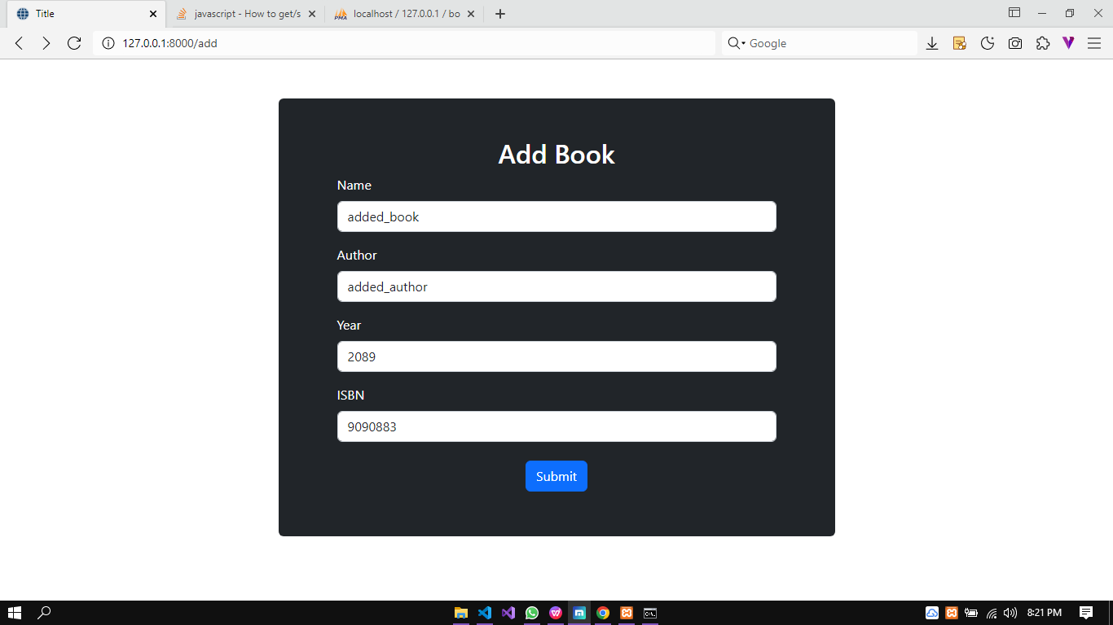

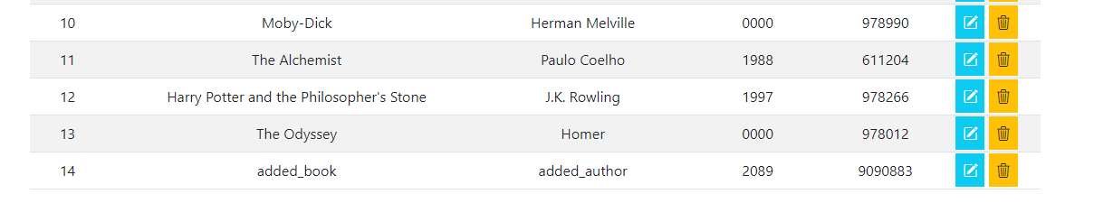

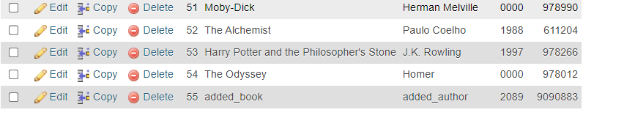

**b.Implement Update Operation in Laravel with GUI.**

**Code snippet:**

public function edit($id,Request $req)

{

$row_affected=DB::update('update bookinfo set name=?,author=?,year=?,isbn=? where id=?',[$req['name'],$req['author'],$req['year'],$req['isbn'],$id]);

return redirect('/');

}

public function fetchdata($id)

{

$r=DB::select('select * from bookinfo where id=?',[$id]);

$url=url('/edit').'/'.$id;

$edit=true;

$data=compact('r','edit','url');

return view('add')->with($data);

}

**Web.php**

<?php

use Illuminate\Support\Facades\Route;

use App\Http\Controllers\dbcontroller;

Route::get('/', [dbcontroller::class,'dbselect']);

Route::get('/add', function()

{

$url=url('/add');

$data=compact('url');

return view('add')->with($data);

}

);

Route::get('/delete/{id}',[dbcontroller::class,'delete'])->name('book.delete');

Route::get('/edit/{id}',[dbcontroller::class,'fetchdata']);

Route::post('/edit/{id}',[dbcontroller::class,'edit'])->name('book.edit');

Route::post('/add',[dbcontroller::class,'add']);

**Final outcome:**



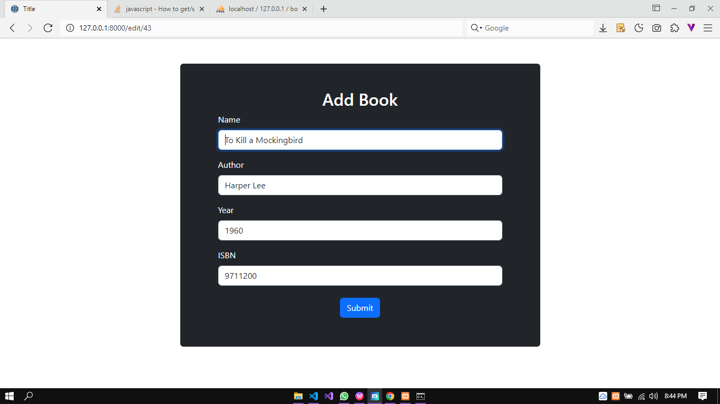

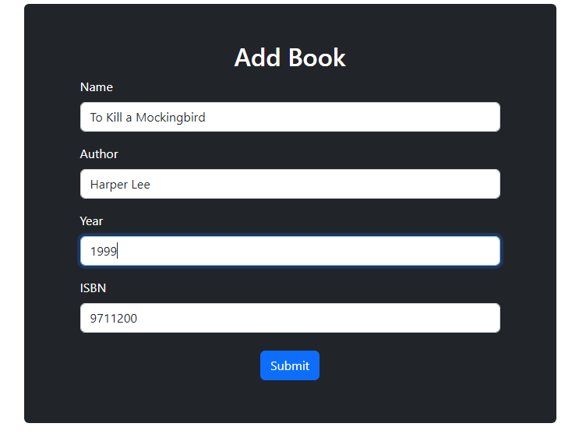

Changing year to 1999

